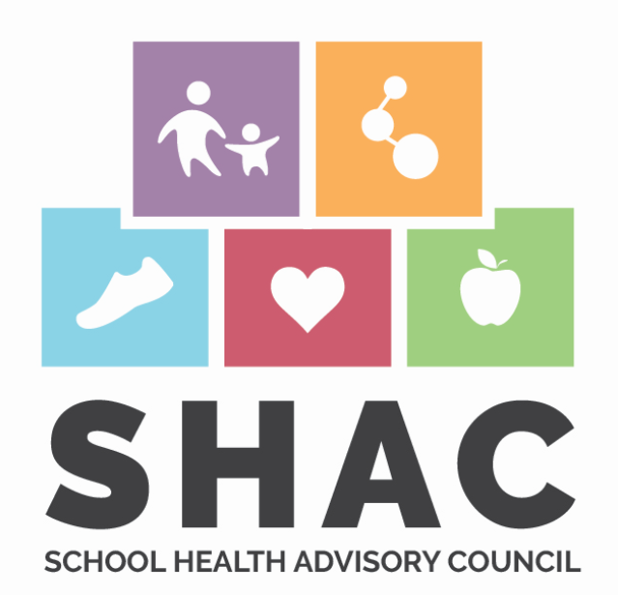

**Tidehaven ISD SHAC Meeting**

Wednesday, March 29, 2023

4:00pm

Tidehaven High School Library or Google Meet

**Agenda**

1. Welcome
2. Old Business:

Puberty Education

Backpack Program

1. New Business:

AgriLife Vaping Presentation

7th grade vaccination requirements

Fitness Gram- elementary

1. Next meeting scheduled for: 9/13/23
2. Adjournment

**THE ROLE OF THE SCHOOL HEALTH ADVISORY COUNCIL (SHAC):**

The School Health Advisory Council (SHAC) serves exclusively in an advisory role, assisting the district in ensuring that local community values and health issues are reflected in the district’s health education instruction.

The committee meets throughout the school year to develop recommendations in multiple areas of student health and well-being including school safety, mental health supports, social and emotional well-being, health and nutrition provisions, and sex education.

*All meetings will be video and audio recorded. All meeting agendas, minutes, and video recordings are available on the Tidehaven ISD website under Healthcare.